**Weather App using Python**

Weather app is a simple tkinter based application which fetches data from API and shows weather results according to location .

It is a simple desktop based application to check the weather details.

Weather App is a tkinter based weather application which fetches data from openweathermap API.

<https://openweathermap.org/api>

**Objectives:**

* Make a simple GUI for the weather app through tkinter.
* Call the Openweathermap API to get weather information .
* Location input boxes which searches for cities and displays its weather.
* Make an interface for 2-3 days weather forecast for the give city**(Optional).**

**Components:**

This weather app consists of :

* Tkinter(GUI)
* Openweathermap API (access token)

Tkinter is the standard GUI library for Python. Python when combined with Tkinter provides a fast and easy way to create GUI applications. Tkinter provides a powerful object-oriented interface to the Tk GUI toolkit.

Creating a GUI application using Tkinter is an easy task. All you need to do is perform the following steps −

* Import the Tkinter module.
* Create the GUI application main window.
* Add one or more of the widgets to the GUI application.
* Enter the main event loop to take action against each event triggered by the user.

**Openwearthermap API:**

To get access to weather API you need an API key whatever account you chose from Free to Enterprise.

Activation of an API key for Free and Startup plans takes 10 minutes. For other tariff plans it is 10 to 60 minutes.

We keep right to not to process API requests without API key.

API call:

http://api.openweathermap.org/data/2.5/forecast?id=524901&APPID={APIKEY}

Parameters:

APPID {APIKEY} is your unique API key

Example of API call:

[api.openweathermap.org/data/2.5/forecast?id=524901&APPID=111111111](http://samples.openweathermap.org/data/2.5/forecast?id=524901&appid=b1b15e88fa797225412429c1c50c122a1)

**Generation of a unique API key:**

Go through the instructions for generating the API ID in the page link given below and then click sign-up to make an account.

<https://openweathermap.org/appid>

After you sign up go to the API keys page

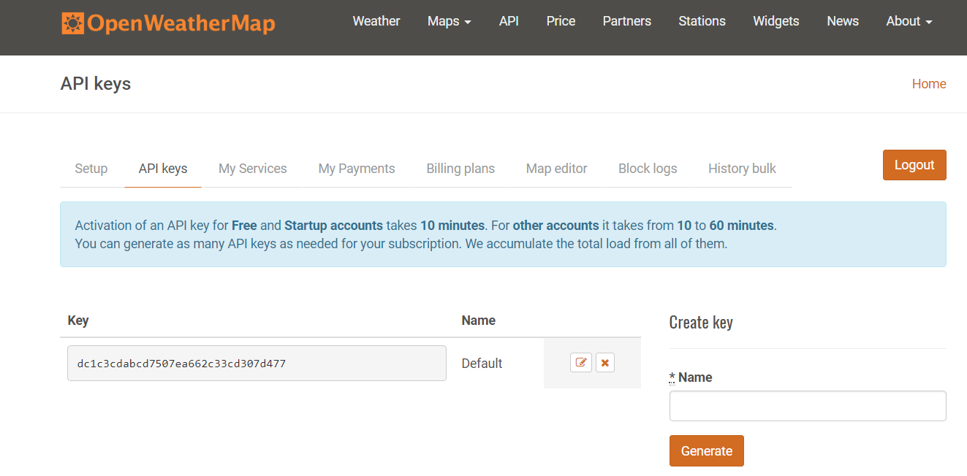

Generate an API key in the create key section with a name.Although the API key take about an hour to activate.

Call the API using the above mentioned way:

http://api.openweathermap.org/data/2.5/forecast?id=524901&APPID={APIKEY}

**Workflow:**

* Make a tkinter GUI interface for the weather app that displays the weather for the city that the user has input.
* Make a input box which acts as the search bar for the city for which the weather is to be displayed.
* Link the API through the GUI using the API access key generated.
* Make a interface for next 2-3 days weather forecast.(Optional)

**Image samples for the program:**

